DELIVERABLE-1 REPORT

PROJECT DETAILS
Project Title: Online Ticket Booking System
Group Name: Group 10
Group Members: Lohith Kumar Velkuri, Srikanth Reddy Ettem, Vynatheya Reddy Vuppunutula, Kiran Kumar Raju Ganga Raju

PROJECT DESCRIPTION
We plan to develop a web application where registered users can purchase tickets to events, concerts and so forth. The application will cover events from various cities and will also provide event and venue information. The aim of the project is to provide an application that is user-friendly and one that provides an interactive experience for the user. Additionally, a user manual and instructions will also be included to answer any questions the users might have in using the application.
In order to develop this application, the language we would be using is Java. In the backend, MySQL database would be used whereas for the frontend, we would use HTML, CSS, jQuery, Javascript, XML. To connect from Java to MySQL database, JDBC will be used.

INITIAL PROJECT PLAN
Initially, the plan is to develop this project in four phases:
- Phase 1: Design completion: Creating the skeleton
- Phase 2: Backend setup: MySQL database and tables with schemas
- Phase 3: Connection between design and backend code with database
- Phase 4: Improving the user interface and testing
In order to track the progress of the project, we are using a project management tool called Agantty.
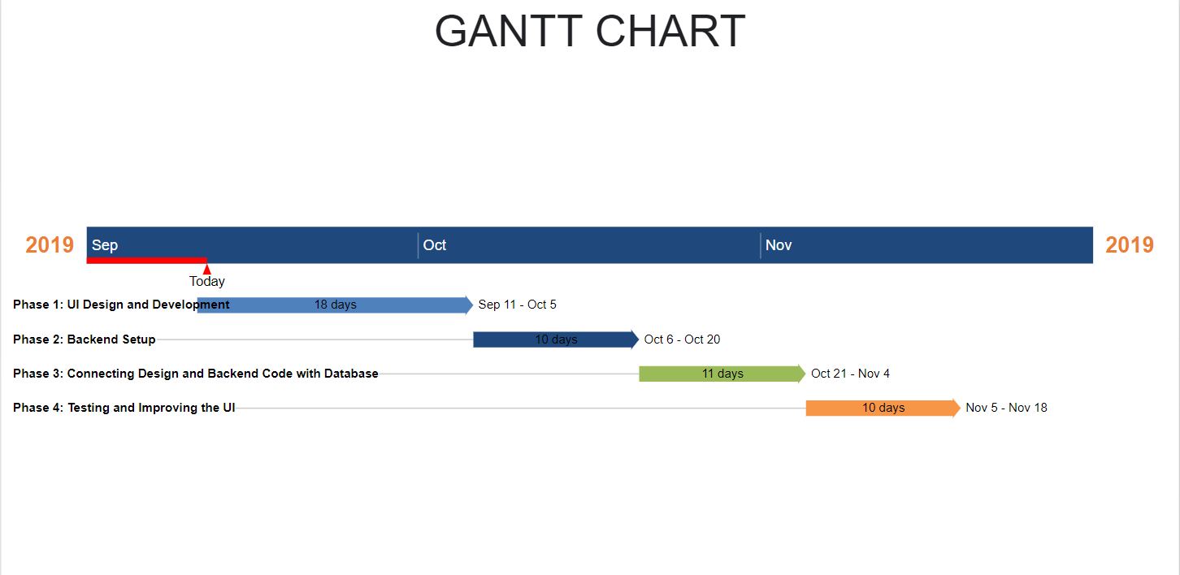

RISK MANAGEMENT
- Schedule Risk
There is always the risk of the project taking longer than anticipated. Our aim is to complete all phases and deliverables of the project on time. To ensure this, our risk management strategy is to develop a Gantt chart outlining every step of the process and to carry out these phases according to the schedule. We also plan to hold regular meetings outside class to discuss and work on the project. Different members of the team would also be assigned various roles to make sure the project gets completed quickly.
- Procedural Risk
These risks may include erroneous implementation and not following the process in an organized manner. To ensure that we do not face any issues in this regard, we would outline clear responsibilities to each group member and also plan on consulting the professor whenever we face any questions regarding the procedure. Other practices that would help us in this aspect would be to briefly study other software projects so that we are aware of a suitable procedure and avoid commonly made mistakes.
- Performance Risk
Most importantly, we need to make certain that the project functions as required after completion. This aspect of the process will be assessed at each stage because this type of risk can give rise to other types of risk as well such as schedule risk and so forth. Therefore, much focus would be placed on ensuring that each module of the application works as expected.

TEAM ROLES
- Lohith Kumar Velkuri: User Interface and backend development
- Srikanth Reddy Ettem: Testing and database management
- Vynatheya Reddy Vuppunutula: Frontend development and User Interface
- Kiran Kumar Raju Ganga Raju: Design and backend development

The above stated would be the primary responsibilities of each member. However, Everyone will be contributing to every modules.

